**Vue Certification mini-project **

# **GOAL: Build a small application that displays job offers with details for each job**

You can see a [video demo of the expected app here](https://youtu.be/0ef2C44J38o).

For this project, we want you to start from the code repository: https://rxgit.radixweb.in/rxprojects/rxpractice/php/vue-project. This will make it easier to start coding as the setup is already done and the API is included.

Once your code is completed, we recommend using Vercel or Netlify to host the project and publish a built version of your code.

To submit your work, you’ll need to provide the link to the Git repository that contains your code, along with a **public URL** to test the app in a browser.

**Important rules and notes - please read carefully:**

You have to **write the code yourself**. Submitting some code already submitted by a friend or colleague is not allowed and will result in disqualification from the certification exam.

Code **quality and best practices matter**. Please do not use the **any** type in Typescript or have a single component in your application. Your code **MUST** use proper types for all variables, methods, parameters, etc. Failure to do so will automatically disqualify your submission.

It should go without saying that **your application will be disqualified and your certification exam marked as failed if the application has bugs, doesn’t implement all of the features, or doesn’t follow the instructions of this document.**  
  
**Finally**, once your application is working, fully tested, and follows best practices (using types and proper component architecture), **submit your work**

**STEP #1 - Implement the ability to list all jobs**

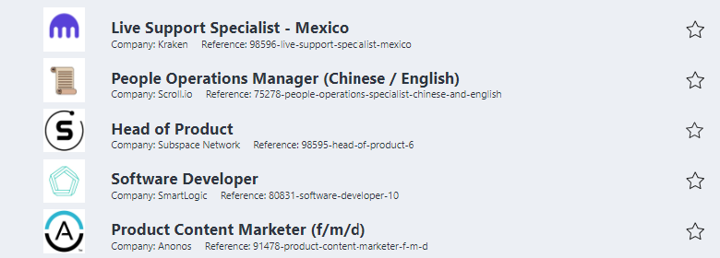

* Jobs must be retrieved from the API included in the project and accessible at the **/jobs** endpoint.
* The following properties from the API call should be displayed: title, companyName, companyLogo and reference.
* Note that styling is not that important for this project, and the layout of your application can be different as long as the application works properly. This is an Vue certification, not a CSS or HTML certification.
* To prepare for step #2, a star icon can be displayed for each job item with the **CSS class ‘icon-star’** and an ID of **“star-{jobId}”**

**STEP #2 - Manage favorites jobs**

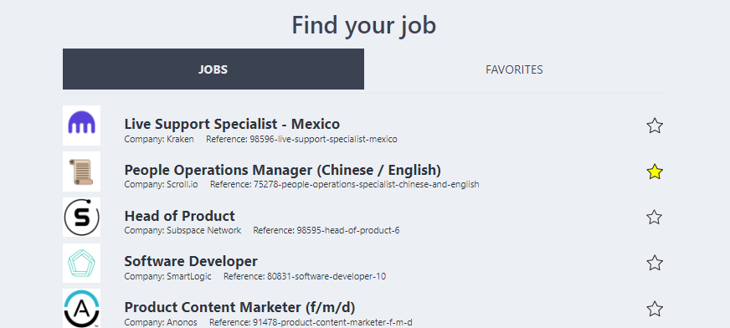

* Two tabs navigation should be displayed: one for jobs, one for favorites. Use the **Vue router** to implement it.
* Use the CSS class **‘active’** to manage the star icon for a job selected as a favorite.
* The click on the star should be managed in order to add or remove the selected job in a favorite list. Clicking on the star for a job already favorited removes the job from the favorites list. The star acts as a toggle button.
* The favorite tab should only display the favorite jobs selected. Favorites **must be persisted in the browser** so a page refresh would not lose the saved favorites.  
  A message must be displayed when there are no favorites.

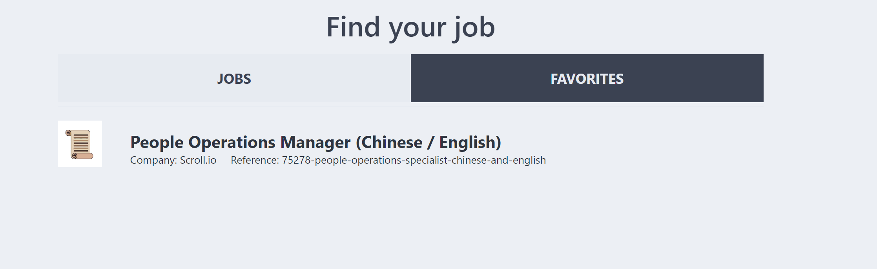

**STEP #3 - Display a detail of the job selected**

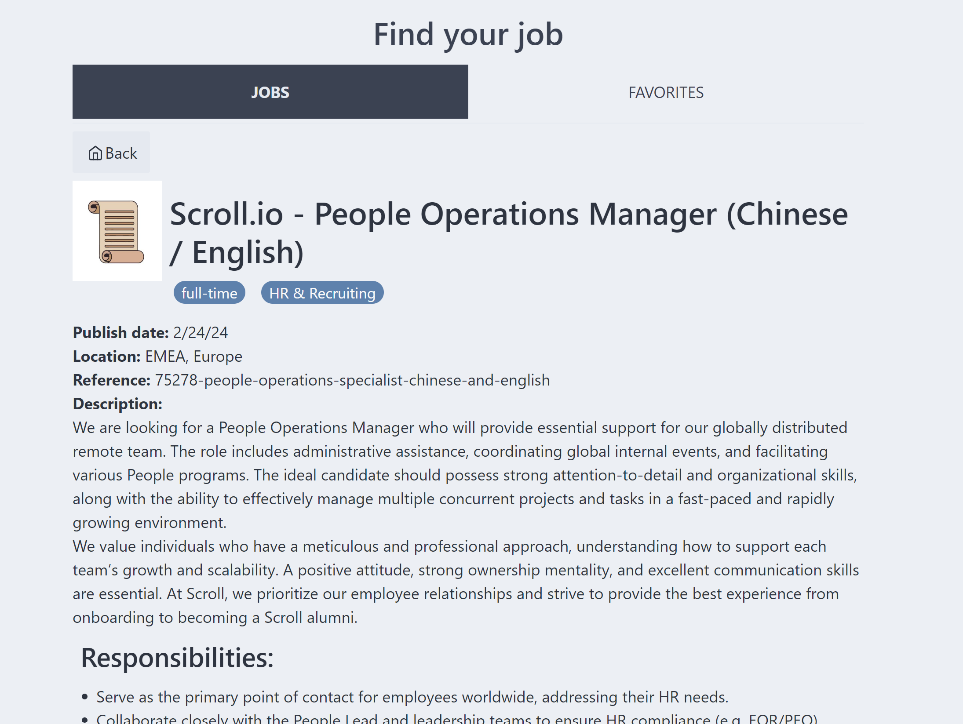

* A simple click on the job title should redirect to a job details. Use the **Vue router** to implement it.
* Job details must be retrieved from the API included in the project and accessible at the **/jobs/:jobId** endpoint.
* On the details page, all the following properties should be displayed: title, companyName, companyLogo, types, industries, publishDate, location, reference and description.
* Note that description is already in an html format, find an easy way to display it as it looks like.
* The user should be able to go back to the jobs list using the back button at the top. Use [this video as a reference if needed](https://youtu.be/0ef2C44J38o).